Practical 19: Button Groups and Combo Boxes

- Using WindowBuilder create the following form.
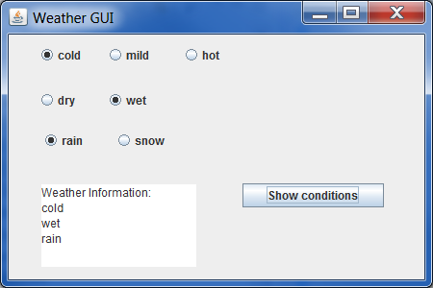
Note: To use a local variable in an anonymous inner class requires the variable to be declared as final. The alternative is to declare all your variables globally as class properties.

To add JRadioButtons to a ButtonGroup:
- Select the radio buttons that are to be in one group
- Right click and go SetButtonGroup | New Standard | give it a name
- You can test whether a button isSelected()
- Create the flag quiz
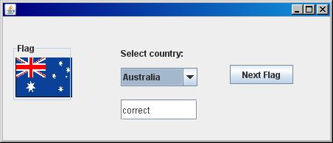
- Use a JComboBox, it has a corresponding String array that holds its values, this is called its model.
- The flag is in a JLabel, lblFlag.setIcon(new ImageIcon(“Russia.png”)); Place all your images at the top level of your project folder.
- Work on your assignment, pass your ArrayList into your GUI.
Here are a few screen shots of previous assignments.
